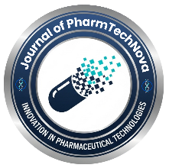 | Journal of PharmTechNova (JPTN)  Journal Link | 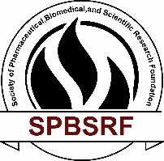
Copyright Agreement
Article Information
- Manuscript Title: ________________________________________________
- Type of Article: Research Article / Review Article / Short Communication / Case Study / Other

Author Declaration
We, the undersigned author(s), hereby submit the above-mentioned manuscript to the Journal of PharmTechNova (JPTN) for consideration for publication. We solemnly affirm that the manuscript is an original work, has not been published previously in whole or in part, and is not currently under consideration for publication in any other journal or medium.
All listed authors have made substantial intellectual contributions to the conception, design, execution, analysis, or interpretation of the research reported in this manuscript. Each author has reviewed and approved the final version of the manuscript and agrees to be accountable for all aspects of the work.
The authors further confirm that all ethical requirements relevant to the study have been fulfilled, and that any conflicts of interest, sources of financial support, or institutional affiliations that could influence the interpretation of the findings have been fully and transparently disclosed in the manuscript.

Author Details
The following table provides the author information and signatures as formal confirmation of agreement to this declaration and the copyright transfer stated below:
S. No. | Author Name | Affiliation | Email | Signature
1
2
3
4

Corresponding Author(s):
Name: ____________________________
Email: ____________________________
Mobile: ____________________________

Copyright Transfer
The author(s) hereby agree that, upon acceptance of the manuscript for publication, the copyright of the article, including all rights to reproduce, distribute, transmit, translate, archive, and disseminate the work in all forms and media now known or hereafter developed, shall be irrevocably transferred to the Journal of PharmTechNova (JPTN).
The journal shall have the exclusive right to publish and distribute the article worldwide, to authorize third-party use, and to include the article in indexing, abstracting, archiving, and promotional databases.

Funding Statement
The author(s) certify that the funding information reported in the manuscript is accurate and complete, including one of the following statements, as applicable:
- “This research received no external funding.”
- “This research was funded by ______________________, Grant No. __________.”

Rights Retained by Authors
Notwithstanding the transfer of copyright, the author(s) retain the right to use the published article for academic, educational, and non-commercial purposes, including inclusion in theses, dissertations, and institutional repositories, provided that appropriate acknowledgment of the Journal of PharmTechNova (JPTN) as the original source of publication is given.

Correspondence
All correspondence concerning this agreement should be addressed to:
Editorial Office
Journal of PharmTechNova (JPTN)

Final Declaration
By signing this agreement, the author(s) confirm that they have read, understood, and agreed to all the terms and conditions outlined above.
Corresponding Author Signature: ____________________________
Name: ____________________________

